

|  |  |  |  |  |  |  |  |  |
| --- | --- | --- | --- | --- | --- | --- | --- | --- |
|  | | | | | | | | |
|  | | STAT 210 - Project Proposal | | | | |  | |
|  |  | | | | | | |  |
|  | | | |  |  | | | |
|  | | | | Fahad AlmatrafiYongkang LongShucheng CaoAbdullah Alhareth |  | | | |
|  | | | | October 29, 2020Applied Statistics and Data AnalysisSTAT 210Professor.Joaquin Ortega Sanchez |  | | | |
|  | | |  | | |  | | |





|  |  |  |  |  |  |  |
| --- | --- | --- | --- | --- | --- | --- |
|  | **Smart Beta?**  **What is the Return of Investing the newly added stocks in S&P 500?** | | | | |  |
|  | |  |  |  |  | |
|  |  | | | | |  |

**Introduction.**

In stock markets, everyone wants to win the money.  Actually, if invest on SPY, which is an ETF (exchange-traded fund) follow the S&P 500 index, from it was founded and stay in the market.  You will get about 7.57% annualized rate of return (0.2 ‰ per day) (Figreu 1). However, some people may not satisfy with the market return, they tried to develop methods to beat market and earn more money.  However, historical data showed that most of active investment methods will lose to market in the end. There is a famous bet. In 2008, Buffet issued a challenge to the hedge fund industry saying that no hedge funds can beat S&P 500 in the next 10 years. He wins in 2015 because his opponent conceded defeat ahead of the contest's scheduled wrap-up on December 31, 2017. (Figure 2) Since most of the people do not have the ability to select stock and time to invest and the active investment will finally lose to the market, smart beta strategies are popular in recent years. The smart beta strategies are passive intersegment that use alternative index construction rules. For example, use equal weighting instead of market capitalization weighting of S&P 500 is a smart beta. Here, we develop a new smart beta strategy that only invest on the newly added stocks in S&P500. We will compare the short-term and long-term return of our smart beta strategy with SPY. We also measure the volatility to evaluate the risk of our smart beta methods.

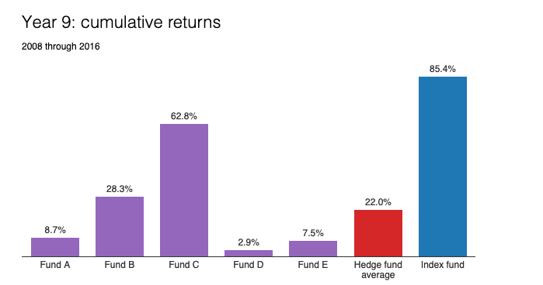

*Figure 2, 9 years cumulative return of 5 hedge funds compared to the index fund Vanguard's S&P 500 (Source: [BRK 2016 letter](http://www.berkshirehathaway.com/letters/2016ltr.pdf))*

**Objective**Our object is to propose a new smart beta strategy that when new stocks are added to S&P 500 components, we invest on those tickets. We would like to see what is our strategy different from investing SPY at the same time. We will use paried t-test and paired wicox test to test whether the 1, 3, 5 and 10 years return is different. We also like to analyze the volatility of the price over time. What’s more, we will construct periodic contribution backtest portfolios based on our strategy, in order to analyze and backtest portfolio returns, risk characteristics, drawdowns, and rolling returns. Finally, we will get a conclusion that what the return and risk of our strategy compared to SPY are.

**Description of the dataset.**

Table 1 contains the historical-components and changes of S&P500 back to 1957. The column date is the S&P 500 component date. The column name is the name of the company. The column value is the symbol of the ticket. The variable is the action, add tickets or remove tickets.We used R pacage quantmod to get the historical price of stocks. The index is the date and we used adjusted price for analysis. Because the adjusted closing price factors in corporate actions, such as stock splits, dividends, and rights offerings, it can reflect the truth historical returns. 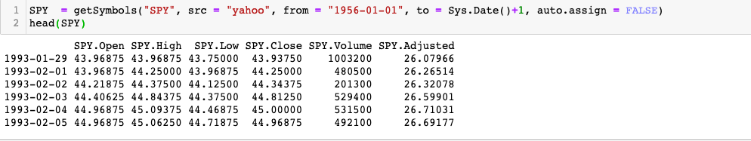

**The scientific goals, specific hypotheses.**Our goals to compare the return on investment (ROI ) and SPY in the short-term 5 years and the long-term 10 years. difference between SPY ( Null hypotheses H0 ) or there is a difference (Alternative HA ) in return investment.

**Methods**

We used one of the most popular and the oldest funds SPDR S&P 500 ETF Trust (SPY) as benchmark. SPY was found on Jan 29, 1993. Therefore, we only focus the newly added components after Jan 29, 1993.

Analysis on One-time investment

1. Find the date the correspond symbols of stokcs added to S&P 500 from 1993.
2. Buy the newly added stocks and SPY as control at the same time.
3. Calculate the ROI of 1, 3, 5, 10 years return of those stocks and SPY, respectively. If the date is not a traded day, we move to the next traded day.
4. We got the paired data of our strategy and SPY’s 1, 3, 5, 10 years return now. Use paired t-test, paired wilcox test to test the difference of return also the variance

Analysis on Periodic Contribution Backtrack Portfolios

1. Find the date the correspond symbols of stokcs added to S&P 500 from 1993.
2. At every time point, invest same money (e.g. 1000 dollors) on the newly added stocks and SPY as control at the same time.
3. Get the portfolio growth curve of our strategy and SPY until now.
4. We analyze the total returns, standard deviation of monthly return, yearly returns to reveal the risks.

**Preliminary plots:**

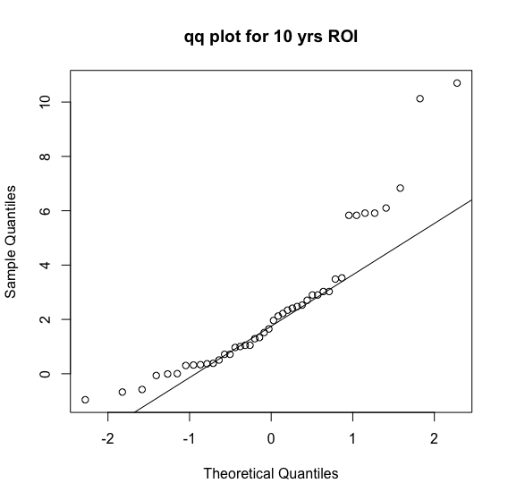

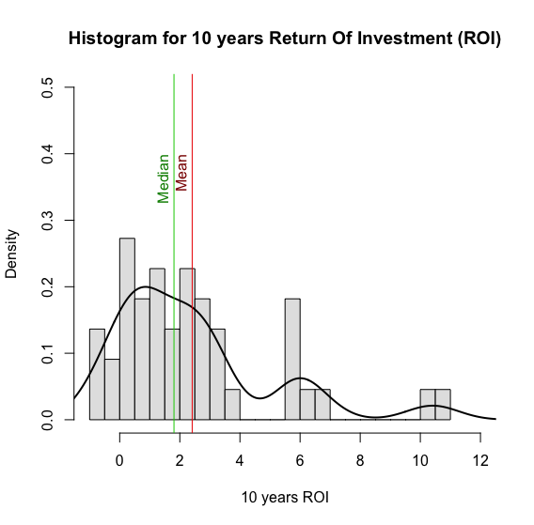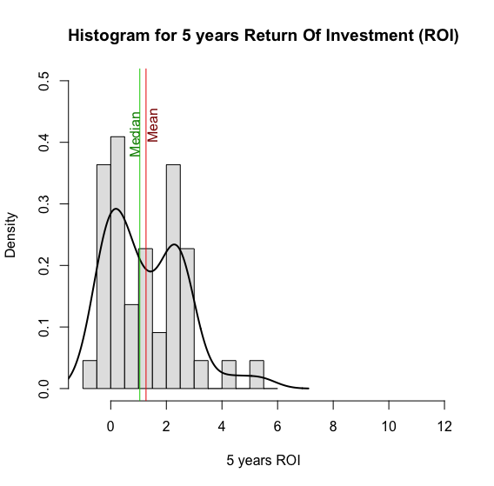

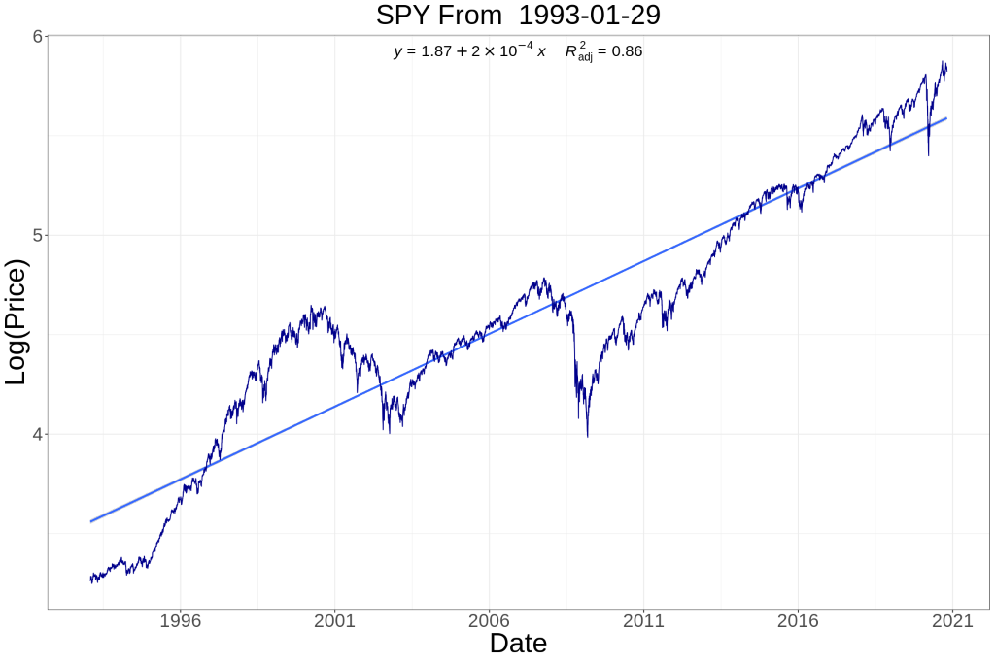

*Figure 1, Historical Price of SPY since it was founded.*

**Plan for analysis and modeling.**Our plan may use the test methods we covered in class. Firstly, we may compare these statistics—mean, weighted mean, median, quantile, variance, standard deviation, and covariance. Secondly, we will do the work related to hypothesis tests. For distribution function, we may use shapiro test and chi-square test. For mean and sd, we may use t test and var test. For test of independence, we may use chi-square test and fisher test. For test of correlation test, we may use correlation test. For analysis of variance, we may use binominal test, paired t test, shapiro test, bartlett test, Kruskal-Wallis test, and Friedman test. We need to determine whether there is a significant difference in the mean and comparing two populations mean.

As for the part of modelling, we may use linear regression model, regression tree, random forest, support vector machine, and analysis time series. We need to filter model independent variables, do regression diagnosis, and analyze outliers.

**Appendix.**

**Notes**

The results do not constitute investment advice or recommendation, are provided solely for informational purposes, and are not an offer to buy or sell any securities.